Digital Design

CSCE 2114-L007

Blake Fasse

March 7, 2017

[bafasse@uark.edu](mailto:bafasse@uark.edu)

Introduction

This lab was split into two parts over two weeks. The first part of lab had the user implement the function F(ABC) = ∑m(0,3,7) on the bread board and build it using only 3 IC and then take that function and rebuild it using only NAND gates. The second part of the lab had the user implement a function in sum of products form that shows active high for all prime numbers between 0 and 15.

Design

The first part of the lab had the user implement the function F(ABC) = ∑m(0,3,7) in sum of products form. The function requires three inverters, three AND gates, and one OR gate. Upon being converted into all NAND gates the function requires seven NAND gates. Since this function requires all NAND gates and inverters cannot be used the inputs were inverted by putting two of the same input into a two input NAND gate in order to invert the input. Also since there is not three input OR gate a three input NOR gate was used and then the input was inverted to achieve the same effect. Below is a picture of the truth table.

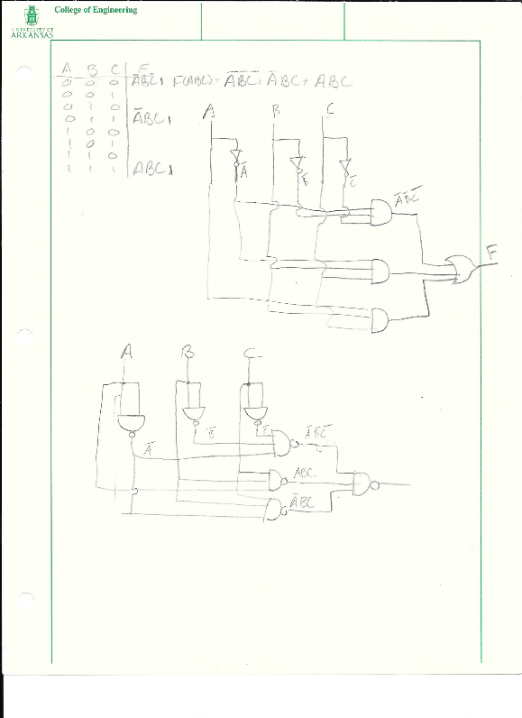

The second part of the lab had the user implement a function in sum of products form that displays active high for all prime numbers between 0 and 15. The function was not given and had to be implemented by the user. The function used was F(ABCD) = ∑m(2, 3, 5, 7, 11, 13). Once the function was put into a Karnaugh Map the function was reduced to F = A’B’C + A’BD + AC’D + AB’D. The function required three inverters, four AND gates, and an OR gate. Since there is not a four input OR gate two of the AND gates were OR together and then those outputs were OR together. A picture of the function and its truth table is shown below.

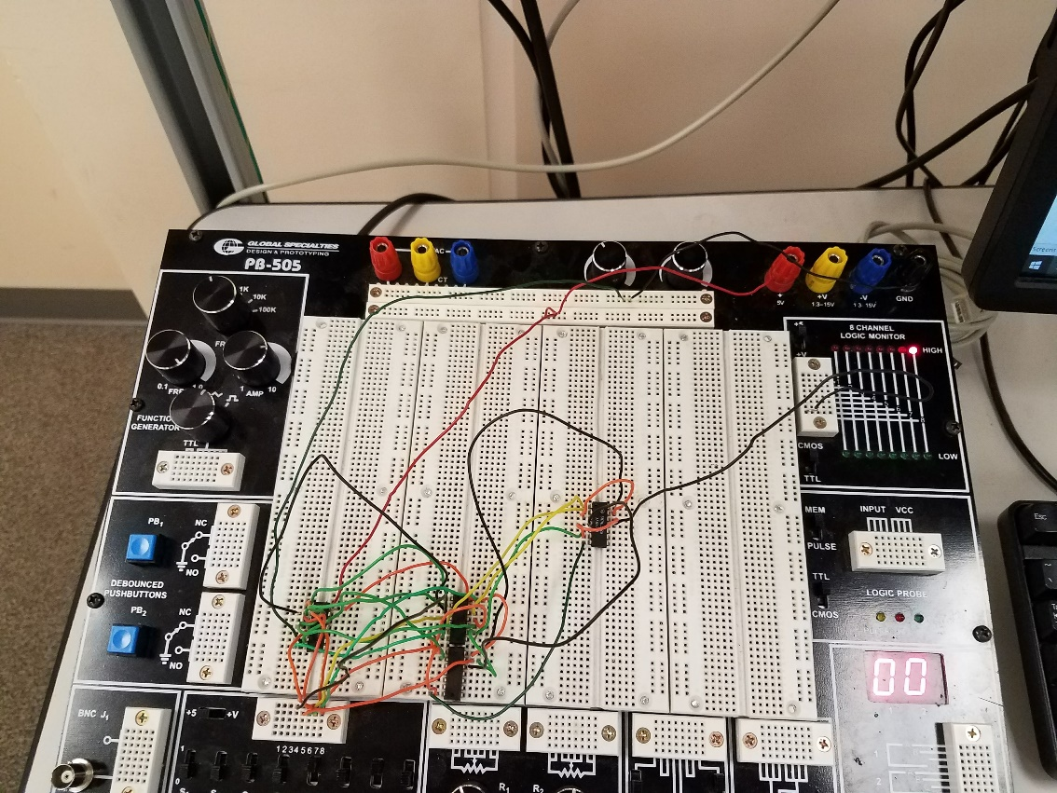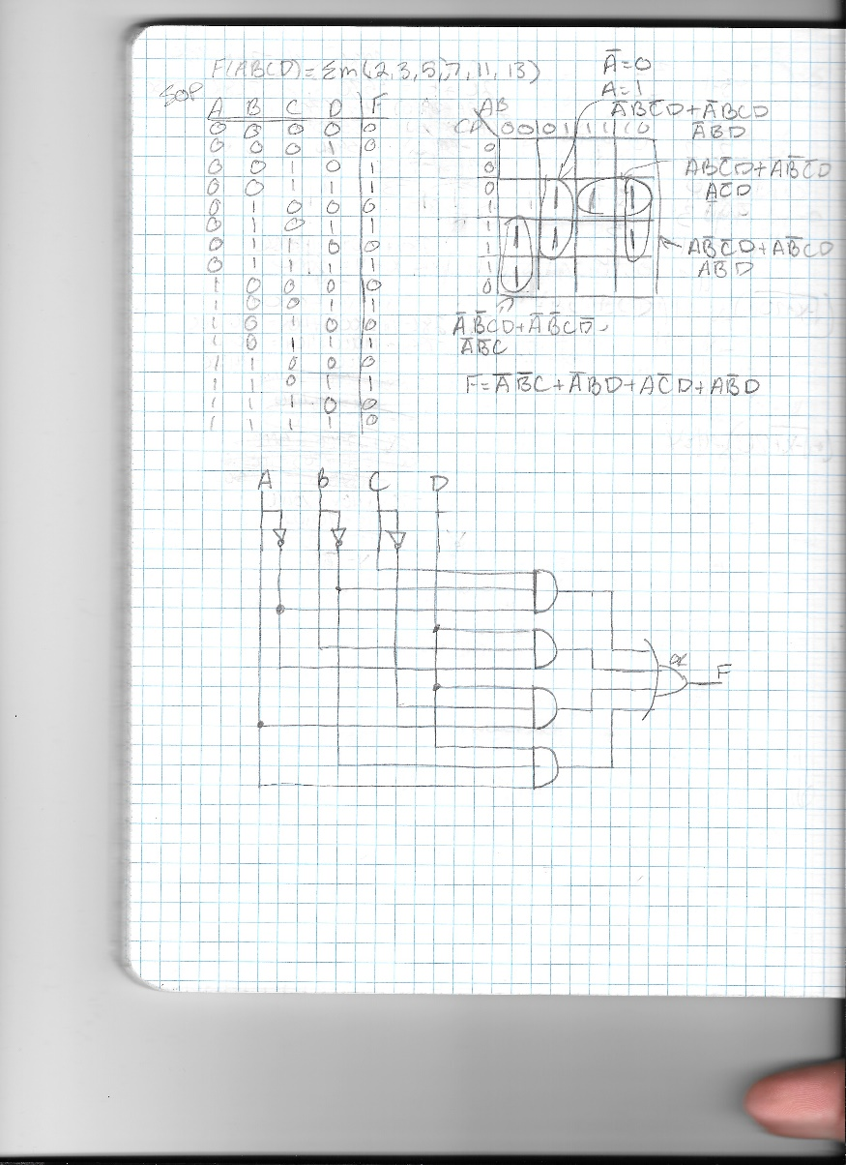

Results

The results of part one of the lab as shown in the pictures shown above. The first part of the lab was more difficult than the second part just due to there not being enough wires of certain lengths. For some reason, even after multiple attempts at rebuilding the circuit it would not be output the desired effect on the bread board. The second part of the lab went off without a hitch and gave the exact out put that was desired.

Conclusion

This lab felt different than the others because it did a lot less hand holding. Things had to be figured out on your own and the vastness of assignment was a little overwhelming, especially if the circuit wasn’t wired correctly it makes it difficult to tell what went wrong as shown in the picture of the bread board above.